**SQL ASSIGNMENT-2**

TASK 1:- UNDERSTANDING THE DATA

1. Describe the data in hand in your own words.

This is the database contain sales of a Superstore. This database structure has five tables as follows-

i) cust_dimen:- which contain details about customer name, their id and their location

ii) market_fact:- It contains customerwise orderwise and marketwise detail of value sales profit,shipping cost and order quantity.

iii) order_dimen:- Contain order no., date, priority.

iv) Prod_dimen:- Containing Product id, category and sub_category.

v) Shipping_dimen:- With shiping date, Id and shipping mode.

Upon, proper database design these tables will get information handy upon querying. These are having dimensions and has facts related to it.

Using market_fact we can derive various insights which will aid in helping decisions regarding product segments sales and profit ability, shipping mode wise etc.

2. Identify and list the Primary keys and Foreign keys for this dataset provided to you (In case you don’t find either primary key, than specially mention this in your answer).

In table,

i) cust_dimen: Cust_id is Primary key, with no Foreign key

II) market_fact: ord_id, prod_id, ship_id and cust_id are Foreign key, with no Primary

key

iii) order_dimen: - ord_id is as Primary key, here Order_id also can be Primary key but it

but we use order_id in shipping_dimen as Foreign key it will help to retrieve details.

iv) Prod_dimen:- Prod_id as Primary key, with no Foreign key.

v) Shipping_dimen:- Shipping_dimen is as Primary key, with order_id as Foreign key.

TASK 2:- BASIS & AND ADVANCED ANALYSIS

Query 1- Write a query to display the Customer_Name and Customer Segment using alias name “Customer Name” from table cust_dimen.

Use superstores;

select customer_name 'Customer Name',customer_segment 'Customer Segment' from

cust_dimen;

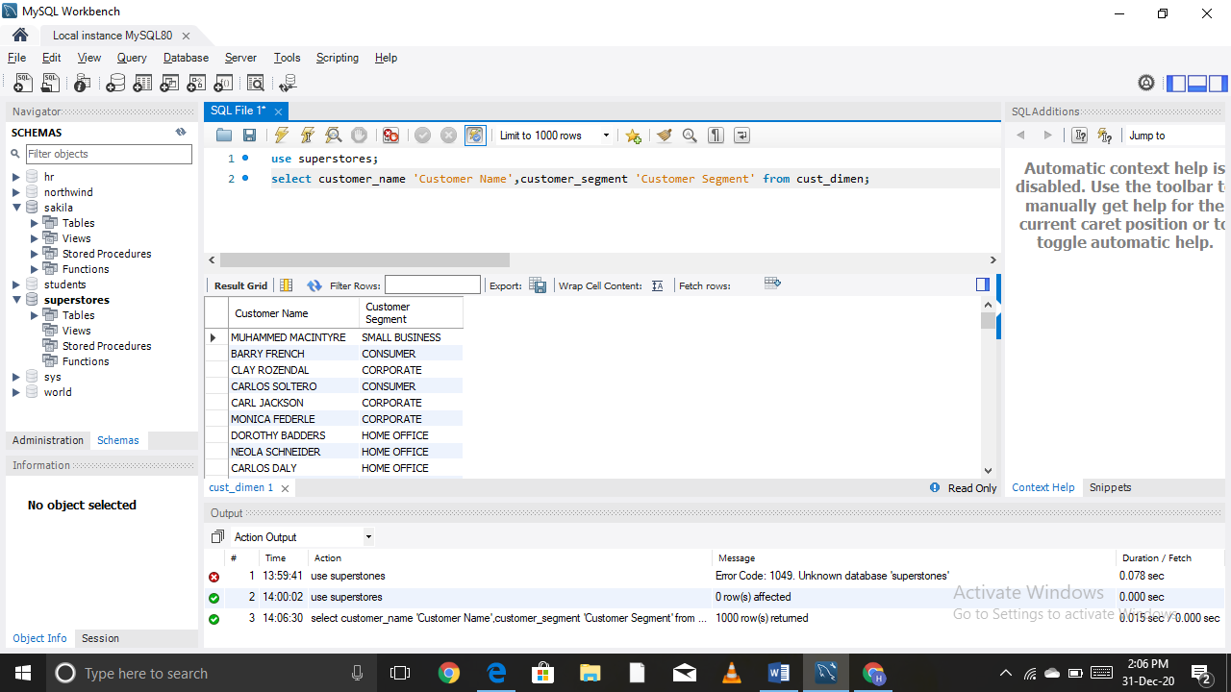

Query 2- Write a query to find all the details of customer from the cust_dimen table order by desc.

Use superstores;

select * from cust_dimen order by cust_id desc;

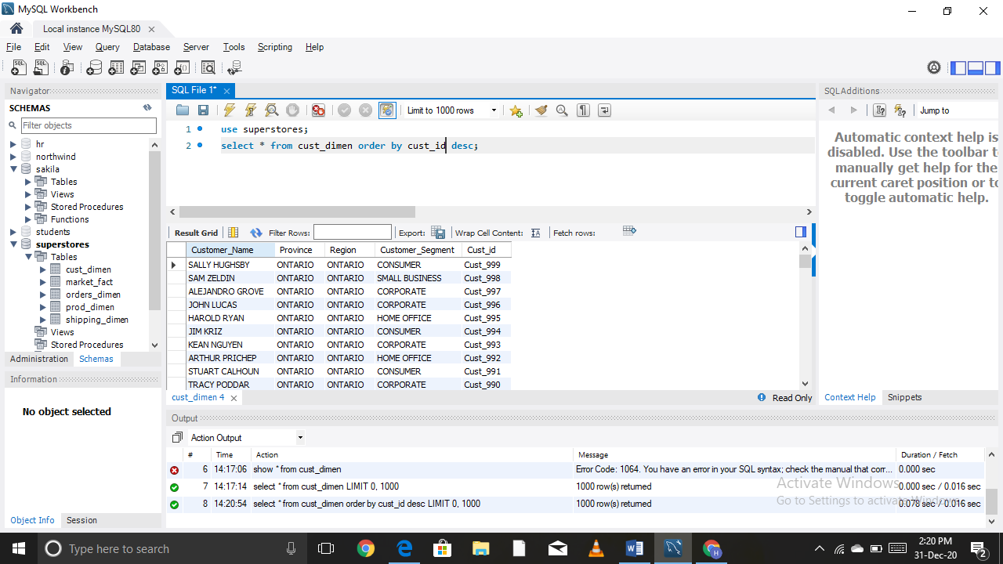

Query 3- Write a query to get the order ID, Order date from table ordes_dimen where ‘Order Priority’ is high.

Use superstores;

select order_id,order_date,order_priority from orders_dimen where

order_priority='high';

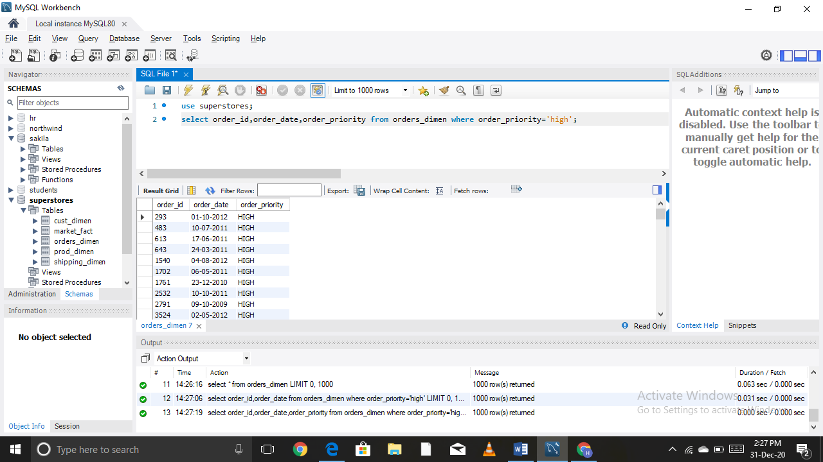

Query 4- Find the total and average sales (display total_sales and avg_sales).

Use superstores;

select round(sum(sales),3) 'Total Sales',round(avg(sales),3) 'Average Sales' from

market_fact;

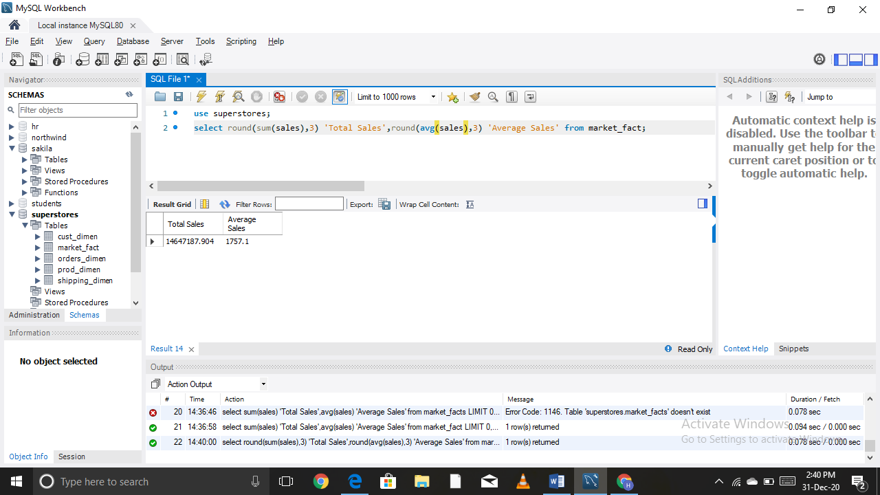

Query 5- Write a query to find maximum and minimum sales from the market_fact table.

Use superstores;

select prod_id,max(sales),min(sales) from market_fact;

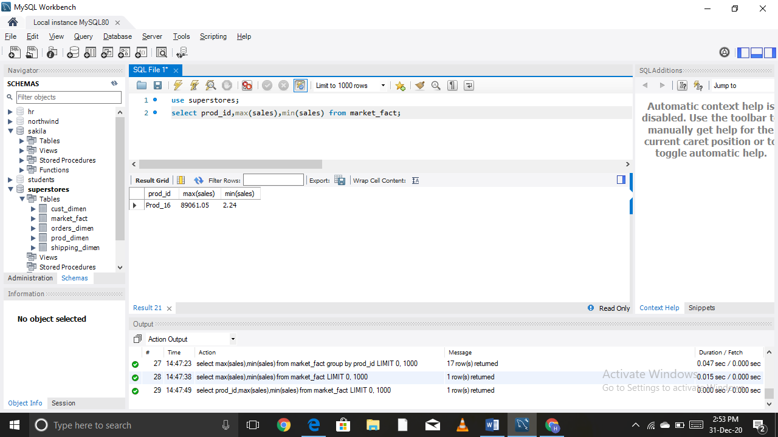

Query 6- Display the number of customers in each region decreasing order of no_of_customers. The result should contain columns Regions,no_of-customers.

Use superstores;

select region,count(cust_id) 'No_of_Customer' from cust_dimen

group by region order by count(cust_id) desc;

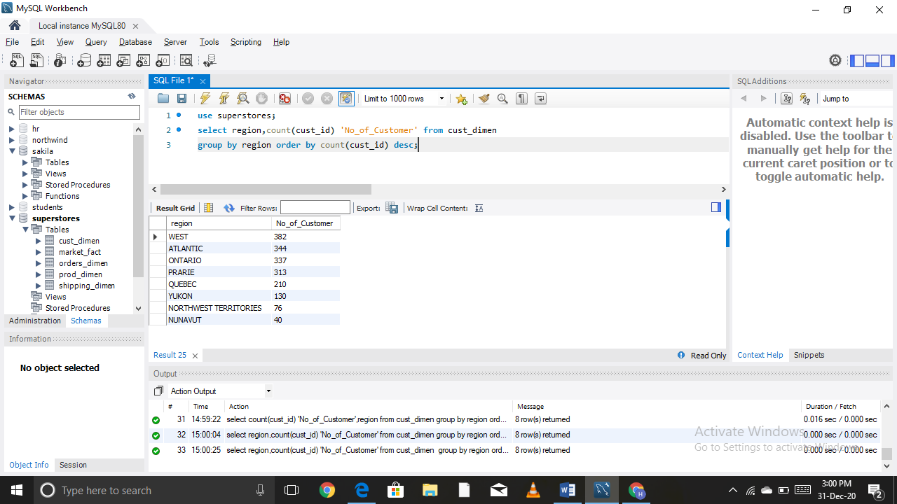

Query 7- Find the region having maximum customers (display the region name and max(no_of_customers).

Use superstores;

select region,max(cust_id) 'No_Of_Customer' from cust_dimen

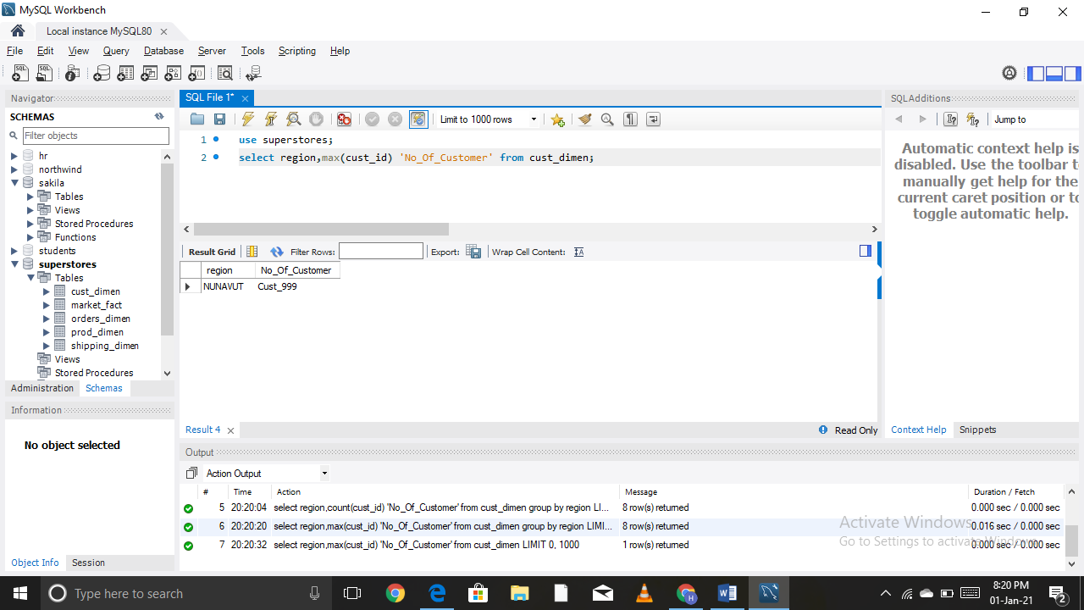

Query 8- Find the all the customer from Atlantic region who have ever purchases ‘TABLES’ and the number of tables purchased (display the customer name, no_of_tables purchased).

Use superstores;

select cust_dimen.Region 'Region',cust_dimen.Customer_Name 'Customer Name',

prod_dimen.Product_Sub_Category 'Product Sub Category',sum(market_fact.Order_Quantity) 'Order Quantity'

from market_fact

join cust_dimen on market_fact.Cust_id = cust_dimen.Cust_id

join prod_dimen on market_fact.Prod_id = prod_dimen.Prod_id

where cust_dimen.Region = "ATLANTIC" and prod_dimen.Product_Sub_Category = "TABLES"

group by cust_dimen.Customer_Name

Order by sum(market_fact.Order_Quantity) DESC;

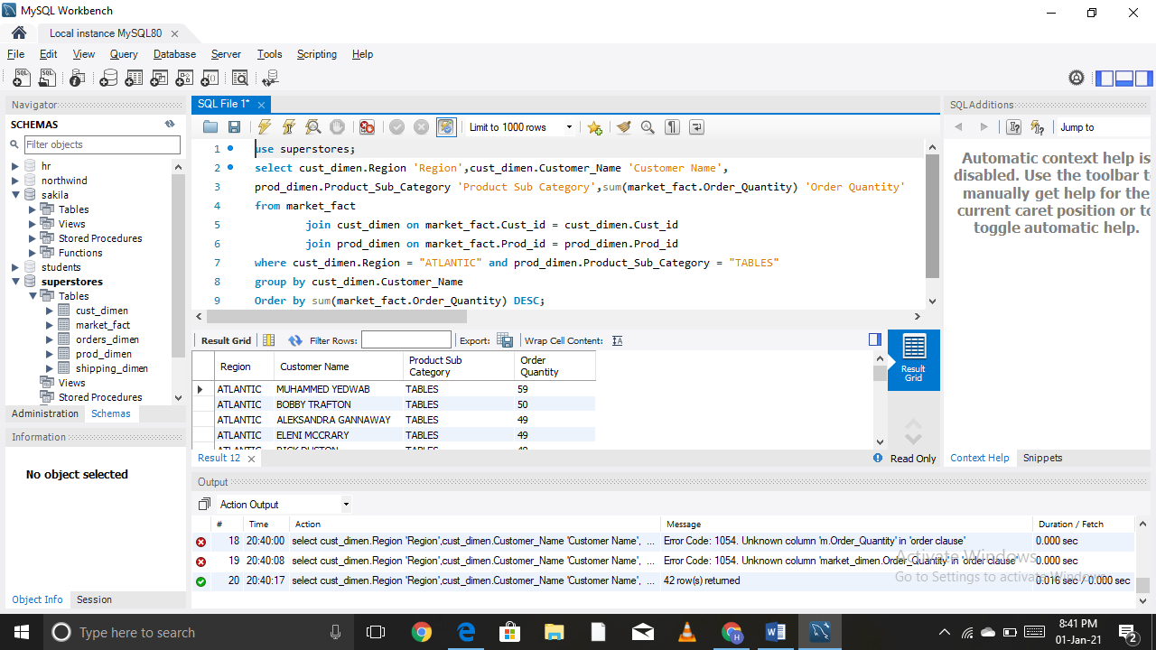

Query 9- Find the all the customer from Ontario province who own small Busnisses. (Display the customer name, no of small business owners).

Use superstores;

select customer_name,customer_segment,province from cust_dimen

where province like 'Ontario' and customer_segment like 'small business';

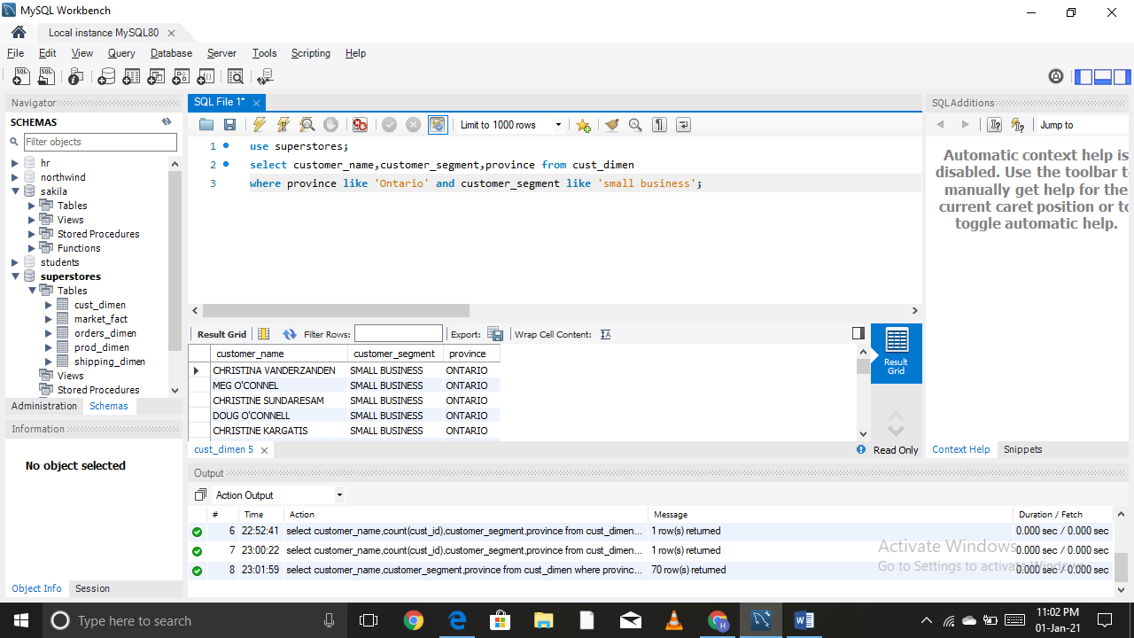

Query 10- Find the number and Id of products sold in decreasing order of products sold (display product id,no_of_products sold).

Use superstores;

select Prod_id,sum(Order_Quantity) 'No_of_Products_Sold' from market_fact

group by Prod_id order by sum(Order_Quantity) DESC;

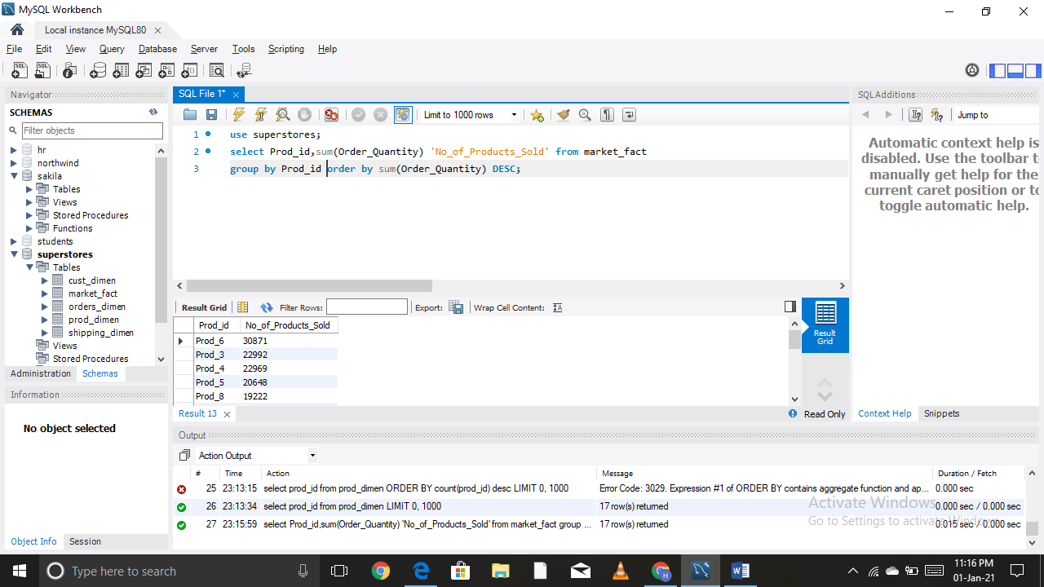

Query 11- Display product Id and product sub category whose product category belongs to furniture and Technology. The result should contain columns product id,product sub category.

Use superstores;

select prod_id,product_sub_category from prod_dimen

where product_category like 'FURNITURE' or product_category like 'TECHNOLOGY';

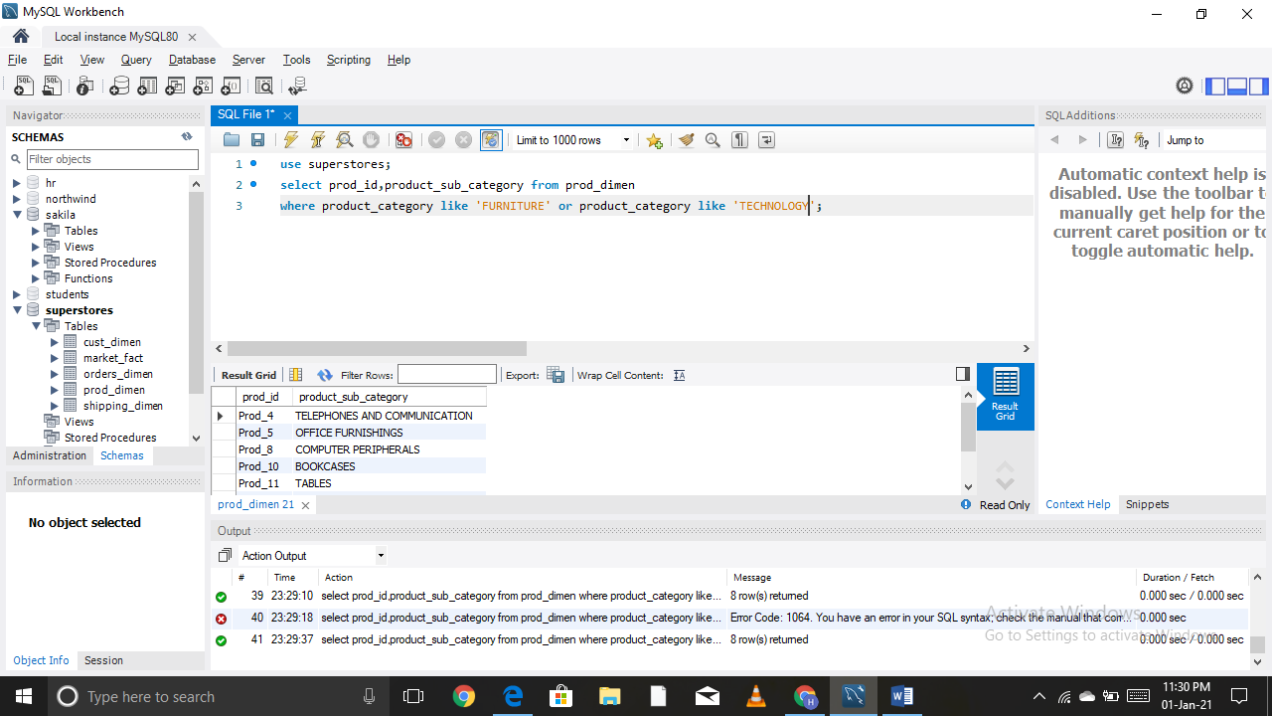

Query 12- Display the product categories in descending order of profits (display the product category wise profits i.e. product_category, profits)?

Use superstores;

select prod_dimen.product_category 'Product Category',round(sum(market_fact.profit),3) 'Profit'

from market_fact

join prod_dimen on market_fact.prod_id= prod_dimen.prod_id

GROUP BY prod_dimen.product_category ORDER BY sum(market_fact.profit) desc;

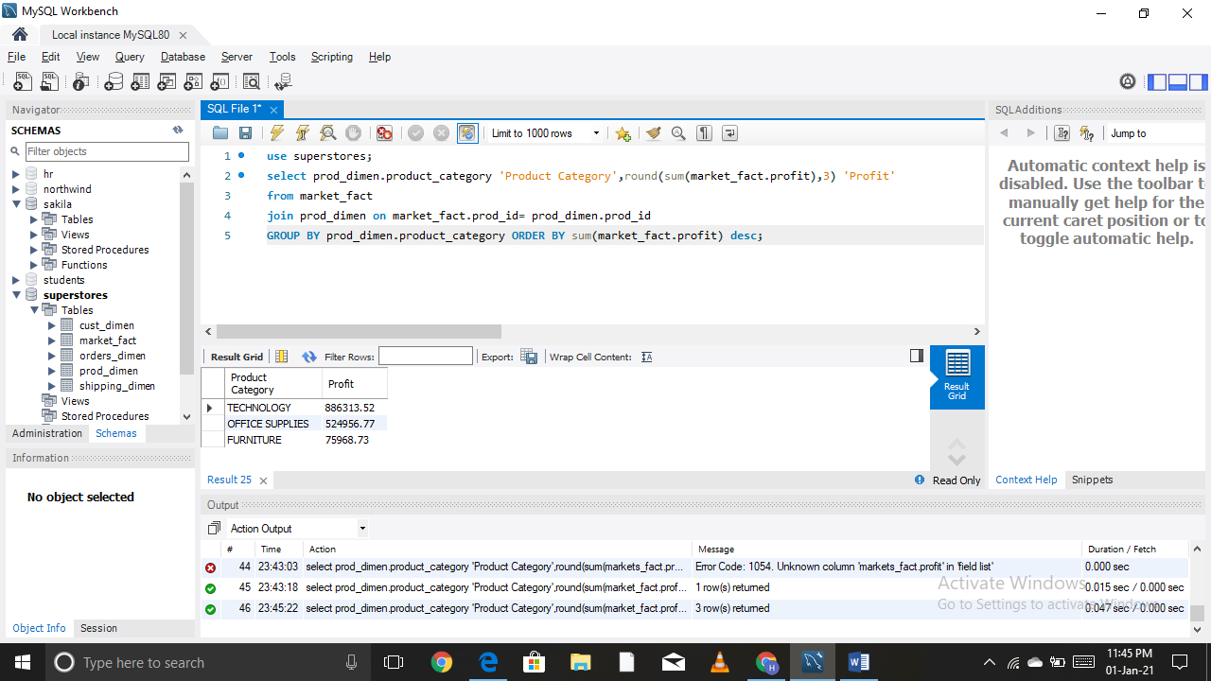

Query 13- Display the product category, product sub_catagery and the profit within each subcatagery in three columns.

Use superstores;

select prod_dimen.product_category 'Product

Category',prod_dimen.product_sub_category, round(sum(market_fact.profit),3) 'Profit'

from market_fact

join prod_dimen on market_fact.prod_id= prod_dimen.prod_id

GROUP BY prod_dimen.product_category ORDER BY sum(market_fact.profit);

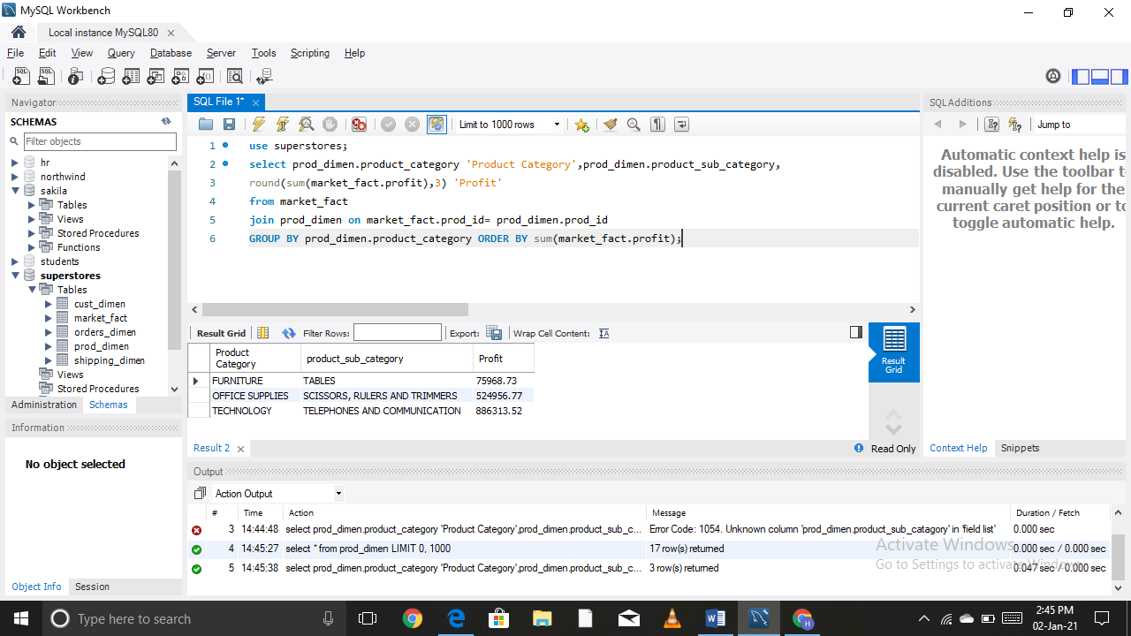

Query 14- Display the order date , order quantity and the sales for the order.

Use supertores;

select orders_dimen.order_date,market_fact.sales,market_fact.order_quantity from

market_fact

join orders_dimen on market_fact.ord_id = orders_dimen.ord_id

group by orders_dimen.order_date;

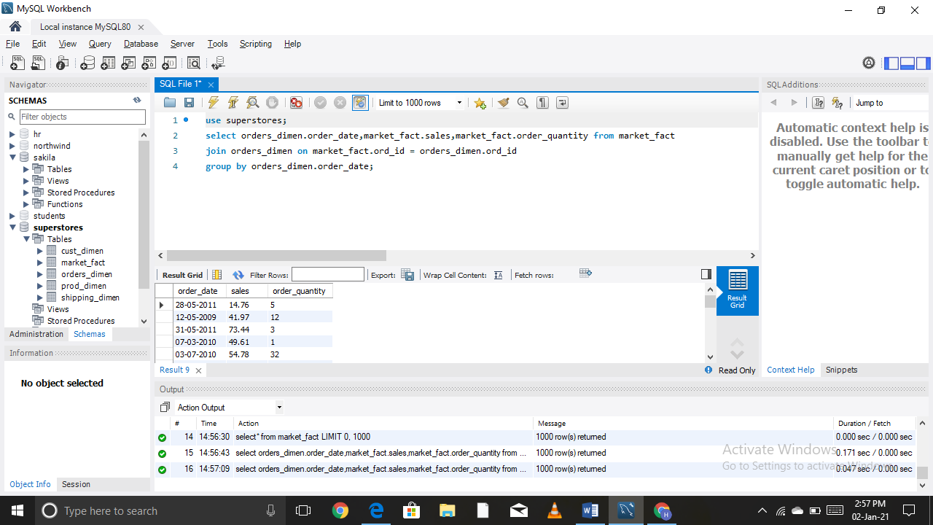

Query 15- Display the names of customer whose name contains the.

(i) Second letter as “R”

Use superstores;

select customer_name from cust_dimen where customer_name like '_r%';

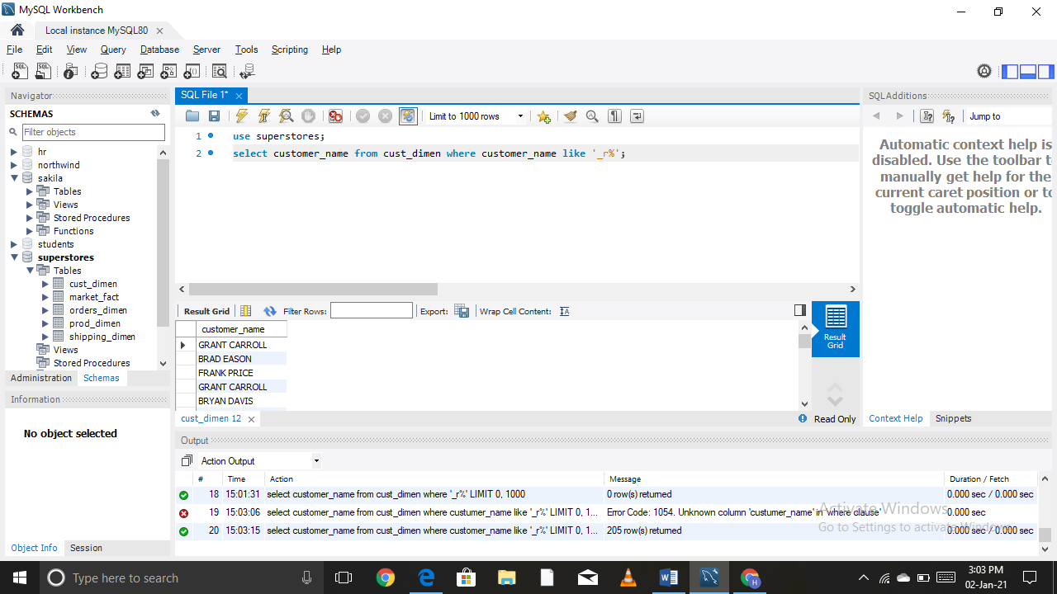

(ii) Fourth letter as “D”

Use superstores;

select customer_name from cust_dimen where customer_name like '___D%';

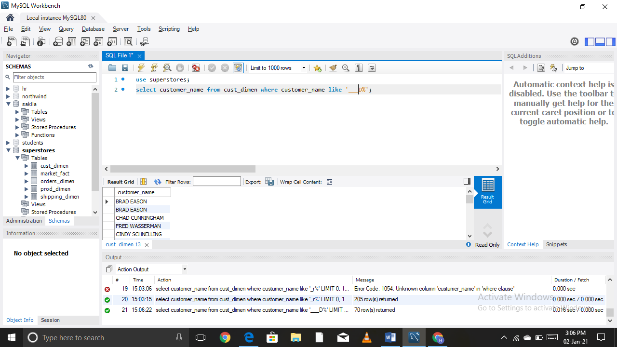

Query 16- Write a SQL query to make a list with cust_id, sales, customer Name and their region where sales are between 1000 and 5000.

Use superstores;

Selectcust_dimen.customer_name,cust_dimen.region,cust_dimen.cust_id,

market_fact.sales from market_fact

join cust_dimen on market_fact.cust_id = cust_dimen.cust_id

where sales between 1000 and 5000 GROUP BY cust_dimen.cust_id;

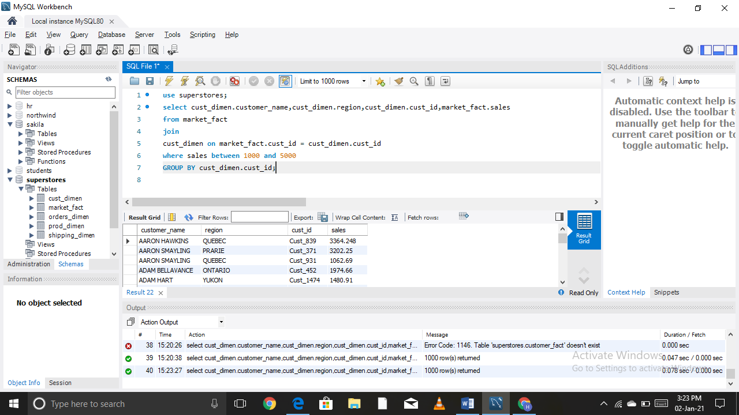

Query 17- Write a query to find the 3rd highest sales.

Use superstores;

select sales from market_fact ORDER BY 'sales' desc limit 2,1;

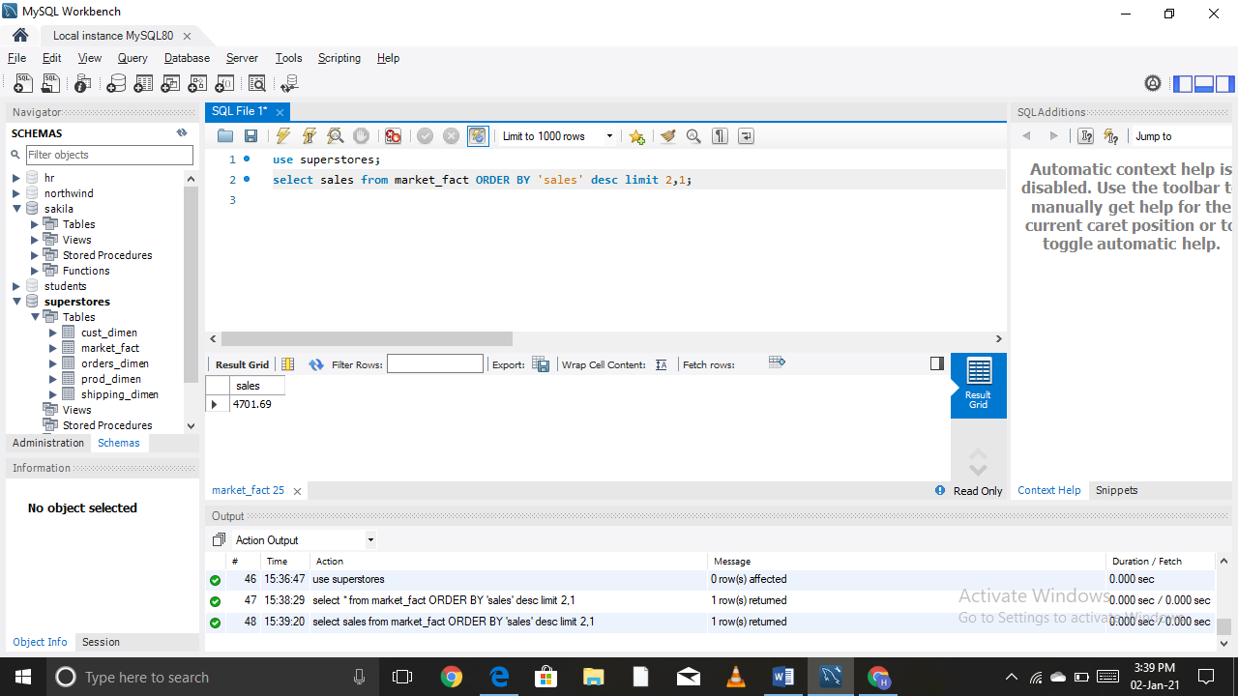

Query 18- Where is the least profitable product subcategory shipped the most? For the least profitable product sub_category, display the region-wise no_of_shipments and the profit made in each region in decreasing order of profits (i.e region,no_of_shipments, profit_in_each_region)

NOTE-You can hardcode the name of the least profitable product subcategory).

Use superstores;

select cust_dimen.Region 'Region',count(market_fact.Ship_id) 'No of Shipments',

round(sum(market_fact.Profit),3) 'Profit in each region' from market_fact

join cust_dimen on market_fact.Cust_id = cust_dimen.Cust_id

join prod_dimen on market_fact.Prod_id = prod_dimen.Prod_id

Where Product_Sub_Category = (Select prod_dimen.Product_Sub_Category from

market_fact

join prod_dimen on market_fact.Prod_id = prod_dimen.Prod_id

group by Product_Sub_Category order by sum(market_fact.Profit) LIMIT 1)

group by cust_dimen.Region order by sum(market_fact.Profit);

